**Level 1: PC Tower Case**

**Outline**

Learn about the internals of a standard PC case by examining physical samples and selecting and labeling images found on-line. Gain deeper knowledge by researching and reporting on specific components.

**Questions**

1. Find one (or more) images that clearly show the internals of a PC Tower Case.   
   (i.e. Google images using keywords “PC Case Internals”)
2. Clearly label the following components (using arrows) on your image of the PC case internals:
   1. Motherboard
   2. Power Supply
   3. Hard Disk Drive
   4. Optical Disk Drive (e.g.DVD)
   5. USB Expansion Ports
   6. Monitor Port
   7. Audio Ports
   8. Ethernet Port
   9. Cooling Fan

Power Supply

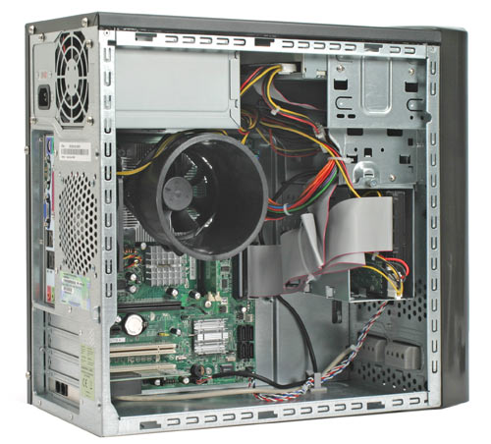

Hard Disk Drive

Optical Disk Drive

Monitor Port

Audio Ports

Cooling Fan

Mother Board

USB Expansion Ports

1. Research more in-depth about “Motherboards”. Make notes on the following:
   1. What different versions are currently available (speed and capacity)

There are 4 types of motherboards

1. AT
2. XT
3. BABY AT
4. ATX
   1. How the component has changed since the 1980’s
5. Research more in-depth about “Hard Disk Drives”. Make notes on the following:
   1. What different versions are currently available (speed and capacity)
6. Parallel Advanced Technology Attachment (PATA)
7. Serial ATA (SATA)
8. Small Computer System Interface (SCSI)
9. Solid State Drives (SSD)
   1. How the component has changed since the 1980’s

**Level 2: PC Motherboard**

**Outline**

Learn about the structure of a standard PC motherboard by examining physical samples and selecting and labeling images found on-line. Gain deeper knowledge by researching and reporting on specific components.

**Questions**

1. Find one (or more) images that clearly show the layout of a PC Motherboard.   
   (i.e. Google images using keywords “PC Motherboard”)
2. Clearly label the following components (using arrows) on your image of the PC motherboard:
   1. CPU fan*
   2. RAM Memory*
   3. Disk Drive Interface (IDE or SATA)*
   4. GPU Graphics Processor (either on-board or Graphics Card)*
   5. Sound Processor (either on-board or Sound Card)*
   6. Wi-Fi / Ethernet Network Interface (either on-board or Graphics Card)

GPU

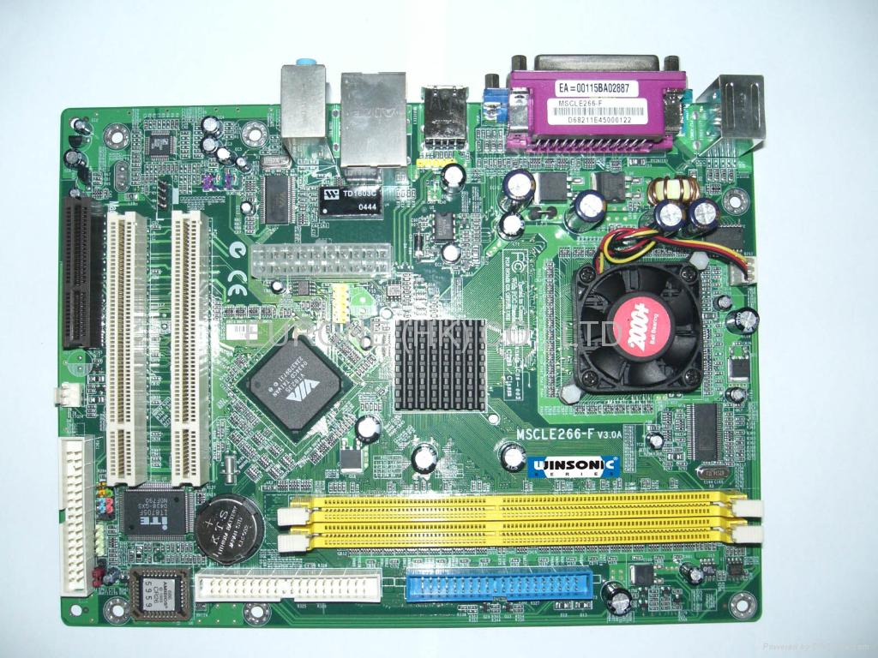

IDE Connecter

RAM Memory

CPU Fan

Sound Processor

1. Research more in-depth about “CPU Processor Chip”. Make notes on the following:
   1. What different versions are currently available (speed and capacity)

<http://www.informit.com/articles/article.aspx?p=130978&seqNum=4>

* 1. How the component has changed since the 1980’s

<https://www.computerhope.com/history/processor.htm> 🡨 Timeline if the CPU history

1. Research more in-depth about “RAM Memory”. Make notes on the following:
   1. What different versions are currently available (speed and capacity)
   2. How the component has changed since the 1980’s

**Level 3: Peripheral Devices**

**Outline**

Learn about how peripheral devices are connected to the back side of a typical PC tower case. Examine physical samples, select and labeling images found on-line and gain deeper knowledge by researching and reporting on specific components.

**Questions**

1. Find one (or more) images that clearly show the layout of the back of a typical PC tower case.   
   (i.e. Google images using keywords “Back Of PC Tower”)
2. Clearly label the following components (using arrows) on your image of the back of a typical PC tower case:
   1. Power cord and power switch
   2. Monitor Interface (VGA or DVI or HDMI)
   3. Mouse Interface (USB or PS/2)
   4. Keyboard Interface (USB or PS/2)
   5. USB Ports
   6. Audio Inputs / Outputs
   7. Ethernet Interface

1. Research more in-depth about “Monitor Technology”. Make notes on the following:
   1. What different versions are currently available (e.g. VGA / DVI, Flat Panel Technology))
   2. How the component has changed since the 1980’s (e.g. Display Resolution, Technology)
2. Research more in-depth about “External Portable Storage”. Make notes on the following:
   1. Floppy Disk

A floppydisk is a magnetic storage medium for computer systems (<https://study.com/academy/lesson/what-is-floppy-disk-definition-advantages-disadvantages.html>) **!!NOT MY WORDS!!**

* 1. CD-ROM / DVD / Recordable CD/DVD

CD-ROM (Compact Disc, read-only-memory) is an adaptation of the CD that is designed to store computer data in the form of text and graphics, as well as hi-fi stereo sound (<https://whatis.techtarget.com/definition/CD-ROM>) **!!NOT MY WORDS!!**

* 1. USB Memory Drives

A plug-and-play portable **storage** device (<https://searchstorage.techtarget.com/definition/USB-drive>) **!!NOT MY WORDS!!**

* 1. Compact Flash Memory

CompactFlash (CF) is a flash memory mass storage device used mainly in portable electronic devices. (<https://en.wikipedia.org/wiki/CompactFlash>) **!!NOT MY WORDS!!**

* 1. Cloud Based Storage

**Cloud storage** is a **cloud computing** model in which **data** is **stored** on remote servers accessed from the internet, or "**cloud**." (https://www.techopedia.com/definition/26535/cloud-storage) **!!NOT MY WORDS!!**

**Level 4: PC Component Presentation**

**Outline**

Explore the development and features of a specific PC hardware component through deeper research and investigation. Work in partners to create a short presentation. Deliver the presentation to the class.

Each group will research a unique PC hardware component . Your specific topic will be assigned from the list provided below.

**Presentation Structure**

1. Explain what the PC component does and how it fits together with other components to make up a fully functioning PC.

Often referred to as a monitor when packaged in a separate case, the display is the most-used output device on a computer. The display provides instant feedback by showing you text and graphic images as you work or play.

1. Explain how the PC component works. Provide a diagram (image) showing the main parts of the component.

<https://computer.howstuffworks.com/monitor1.htm>

1. Research the current state of the art of the component in terms speed, capacity (size), and other related factors.
2. Research online suppliers that sell the PC Component. List the specifications for the available products and the cost (price).
3. Research how the PC component has changed and evolved since the early days of PCs in the 1980’s. Cover each of the following topics separately:
   1. Component Speed
   2. Component Size / Capacity
   3. Two other specifications specific to the PC component (ask Mr. Nestor)

**PC Component Topics**

|  |  |  |
| --- | --- | --- |
| **Topic** | **Partner 1** | **Partner 2** |
| Monitor & Display Technology |  |  |